Define Pipelining. Explain arithmetic pipelining.
Pipelining
Definition:
Pipelining is a technique used in computer architecture where multiple instructions are overlapped in execution by dividing the processor into different stages. Each stage performs part of an instruction, and several instructions can be processed simultaneously in different stages, thus improving system throughput.
- It works like an assembly line in a factory.
- While one instruction is being executed, another can be decoded, and a third can be fetched.
- Increases instruction throughput but not the execution time of a single instruction.
Example :5-Stage Instruction Pipeline
Instruction Stream →
┌────────────┬────────────┬────────────┬────────────┬────────────┐
│ IF │ ID │ EX │ MEM │ WB │
│(Fetch) │(Decode) │(Execute) │(Memory) │(Write Back)│
└────────────┴────────────┴────────────┴────────────┴────────────┘

Arithmetic Pipelining
Explanation:
- Arithmetic pipelining is the application of pipelining specifically to arithmetic operations (like addition, multiplication, division).
- Complex arithmetic operations are divided into smaller sub-operations, which are performed in pipeline stages.
- Example: Floating-point addition or multiplication can be split into steps such as:
  - Operand Fetch
  - Exponent Comparison/Alignment
  - Mantissa Operation (Add/Multiply)
  - Normalization & Rounding
  - Result Storage
This allows multiple arithmetic operations to be executed in different stages at the same time.

Diagram
1. General Pipelining Diagram
Instruction Stream →
┌───────────┬───────────┬───────────┬───────────┐
│ Fetch │ Decode │ Execute │ Write Back│
└───────────┴───────────┴───────────┴───────────┘
Each box = stage. Multiple instructions overlap in different stages.

2. Arithmetic Pipelining (Example: Floating Point Addition)
Stage 1: Operand Fetch ──► | A = 2.35 , B = 1.46
Stage 2: Exponent Alignment ──► | Align exponents
Stage 3: Mantissa Addition ──► | Add mantissas
Stage 4: Normalization ──► | Normalize result
Stage 5: Rounding & Storage ──► | Store final result
Pipeline allows next addition to enter Stage 1 while the previous one is in Stage 2, and so on.

Advantages
- Increases throughput of arithmetic operations.
- Better utilization of hardware resources.
- Reduces average execution time per instruction.
Parallel Processing – Definition
Parallel processing is the simultaneous use of multiple processing elements (processors or cores) to solve a computational problem by dividing it into smaller tasks that can be executed concurrently.
- It is used to improve speed and performance of computation.
- Used in: Supercomputers, multiprocessors, multicore CPUs, and GPUs.
Flynn’s Classification of Computers
In 1966, Michael J. Flynn classified computer architectures based on the number of instruction streams and data streams being processed simultaneously.
According to Flynn’s Classification, computers can be categorised into four main groups:
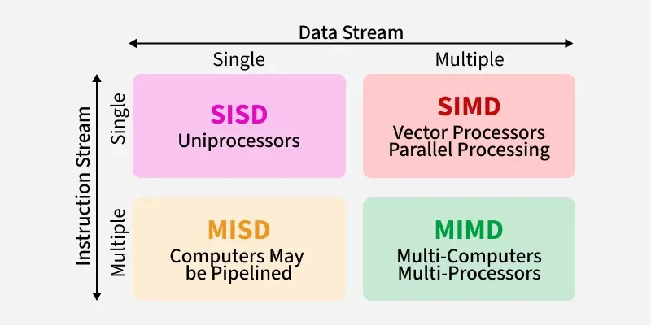
SISD
SIMD
MISD
MIMD
SISD, also known as Single Instruction and Single Data Stream, is a type of computer architecture that is based on a single-processor machine. This machine is capable of executing one instruction at a time on a single data stream.
┌───────────────┐
│ Instruction │
│ Stream │
└──────┬────────┘
│
▼
┌───────┐
│ CPU │
└───────┘
│
▼
┌───────────────┐
│ Data Stream │
└───────────────┘
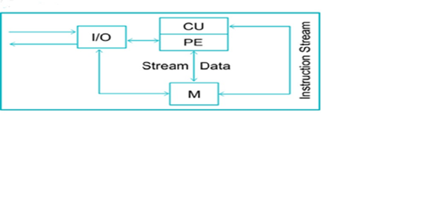PE represents Processing Element, CU stands for Control Unit, and M refers to Memory.
The Control Unit decodes instructions before they are sent to the processing units for execution. The Data Stream is bi-directional, which means data moves between the memory and processors.
SIMD, is known as Single Instruction and Multiple Data Stream, refers to a system comprising numerous processing units governed by a single control unit. This control unit dispatches the same instruction to all processors, but they operate on different data sets.
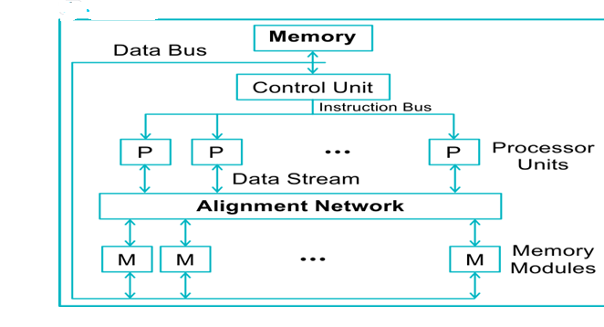
┌───────────────┐
│ Instruction │
│ Stream │
└──────┬────────┘
│
▼
┌───────┐
│ CPU │──► Data 1
└───────┘
│
├──────────────► Data 2
│
├──────────────► Data 3
│
└──────────────► Data N

• One instruction stream operates on multiple data streams simultaneously.
• Suitable for vector processing, graphics, scientific computing.
3. MISD (Multiple Instruction Single Data)
- Multiple instruction streams operate on the same data stream.
- Rare in practice, sometimes used in fault-tolerant systems where different instructions check the same data for errors.
Instr1 → [ CPU1 ] ┐
Instr2 → [ CPU2 ] ┼→ Data Stream
Instr3 → [ CPU3 ] ┘
Example: Systolic arrays, some fault-tolerant military systems.
┌───────────────┐ ┌───────────────┐ ┌───────────────┐
│ Instruction 1 │ │ Instruction 2 │ ... │ Instruction N │
└──────┬────────┘ └──────┬────────┘ └──────┬────────┘
│ │ │
▼ ▼ ▼
┌───────┐ ┌───────┐ ┌───────┐
│ CPU1 │ │ CPU2 │ ... │ CPUn │
└───┬───┘ └───┬───┘ └───┬───┘
└───────────────┬────┴───────────────┬────┘
▼
┌───────────────┐
│ Data Stream │
└───────────────┘
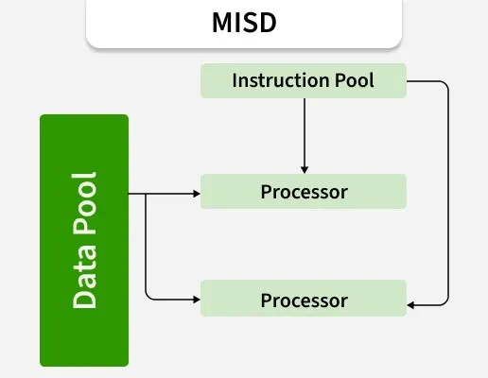

4. MIMD (Multiple Instruction Multiple Data)
Multiple instruction streams operate on multiple data streams simultaneously.
Most powerful and general form of parallel processing.
Used in multiprocessors, multicore CPUs, supercomputers, distributed systems.

┌───────────────┐ ┌───────────────┐ ┌───────────────┐
│ Instruction 1 │ │ Instruction 2 │ ... │ Instruction N │
└──────┬────────┘ └──────┬────────┘ └──────┬────────┘
│ │ │
▼ ▼ ▼
┌───────┐ ┌───────┐ ┌───────┐
│ CPU1 │ │ CPU2 │ ... │ CPUn │
└───┬───┘ └───┬───┘ └───┬───┘
▼ ▼ ▼
Data 1 Data 2 Data N
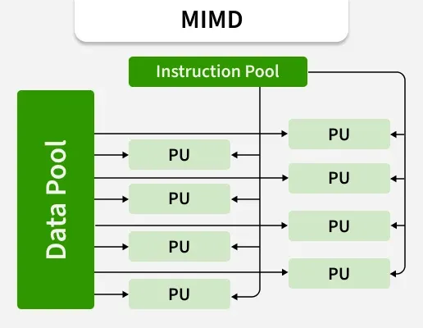
Define instruction pipeline. Explain four segment Instruction Pipeline with its timing diagram.
Instruction Pipeline
Definition:
Instruction pipeline is a technique in computer architecture where different stages of instruction execution are divided into separate segments, and multiple instructions are overlapped in execution.
While one instruction is being fetched, another can be decoded, a third can be executed, and a fourth can be accessing memory or writing back.
This increases instruction throughput and overall CPU performance.

Four-Segment Instruction Pipeline
The four basic segments of an instruction pipeline are:
- Instruction Fetch (IF):
  - Fetch instruction from memory.
  - Place it in instruction register.
- Instruction Decode (ID):
  - Decode opcode.
  - Identify operation & operands.
- Instruction Execute (EX):
  - Perform the required operation using ALU.
  - If branch/jump, calculate next instruction address.
- Write Back (WB):
  - Store the result into the destination register or memory.

Block Diagram (Four-Segment Pipeline)
Instruction → [ IF ] → [ ID ] → [ EX ] → [ WB ] → Result
Each block = stage of the pipeline.

Timing Diagram
Let’s assume each stage takes 1 clock cycle:
Clock Cycle → 1 2 3 4 5 6 7
--------------------------------------------------------
Instr 1 [IF] [ID] [EX] [WB]
Instr 2 [IF] [ID] [EX] [WB]
Instr 3 [IF] [ID] [EX] [WB]
Instr 4 [IF] [ID] [EX] [WB]

Explanation of Timing Diagram:
- At Cycle 1, Instruction 1 is fetched.
- At Cycle 2, Instruction 1 moves to Decode, while Instruction 2 enters Fetch.
- At Cycle 3, Instruction 1 executes, Instruction 2 decodes, Instruction 3 fetches.
- After the pipeline is filled, one instruction completes in every cycle.

Advantages of Instruction Pipeline
- Increased instruction throughput.
- Better CPU utilization.
- Reduces average execution time per instruction.
Describe the applications of Vector processing. Explain in brief about vector operations
Applications of Vector Processing & Vector Operations
Vector Processing – Introduction
Vector processing is the technique of executing one operation on multiple data elements simultaneously using vector processors.
It is widely used in scientific, engineering, and data-intensive applications.

Applications of Vector Processing
- Scientific Computations
  - Solving large matrices, linear algebra, and differential equations.
  - Weather forecasting and climate modeling.
- Engineering Applications
  - Simulation of physical systems (e.g., fluid dynamics, structural analysis).
  - CAD/CAM and finite element analysis.
- Image Processing
  - Image enhancement, compression, and pattern recognition.
  - Graphics rendering in computer graphics.
- Signal Processing
  - Speech recognition, audio filtering, and radar signal analysis.
  - Digital filtering and convolution operations.
- Artificial Intelligence & Machine Learning
  - Vectorized operations in deep learning, neural networks, and natural language processing.
- Supercomputing / High Performance Computing (HPC)
  - Weather modeling, space research, bioinformatics, molecular dynamics.

Vector Operations
Vector operations involve performing arithmetic or logical operations on entire vectors (arrays of data) instead of element by element in scalar mode.
Types of Vector Operations:
- Vector–Vector Operations
  - Operation is performed between two vectors of equal length.
  - Example:
C=A+B where A, B, C are vectors
(Element-wise addition).
- Vector–Scalar Operations
  - A single scalar value operates with every element of a vector.
  - Example:
B=A×k
(Multiplying each element of vector A by scalar k).
- Vector Reduction Operations
  - Reduce a vector into a single value.
  - Example: Sum of all elements of a vector, finding maximum/minimum.
- Vector Product Operations
  - Dot product (inner product) and cross product.
  - Example:
D=∑(Ai×Bi)

Diagram (Vector Addition Example)
A = [2, 4, 6, 8]
B = [1, 3, 5, 7]
-----------------
C = [3, 7, 11, 15]
All additions happen in parallel in a vector processor.
Differentiate parallel processing and pipeline processing.
Difference between Parallel Processing and Pipeline Processing
Aspect | Parallel Processing | Pipeline Processing
Definition | Multiple processors (or cores) execute different instructions simultaneously on different data. | Single instruction is divided into multiple stages, and different stages execute concurrently on different instructions.
Basic Idea | True parallelism using multiple CPUs. | Overlapping of instruction execution like an assembly line.
Hardware Requirement | Requires multiple processors/ALUs. | Can be implemented within a single processor by dividing it into stages.
Instruction Streams | Follows MIMD / SIMD models (multiple instruction/data). | Mostly SISD (single instruction at a time, but overlapped stages).
Execution Style | Different instructions are executed simultaneously. | Same instruction goes through different stages in sequence, but overlapped with others.
Speedup | High performance for independent tasks. | Improves throughput but not individual instruction speed.
Complexity | More complex (synchronization, communication, cost). | Comparatively less complex and cost-effective.
Examples | Multicore processors, GPUs, supercomputers, distributed systems. | Instruction pipelines in RISC processors, arithmetic pipelines (floating-point adders, multipliers).

Simple Diagrams
Pipeline Processing (overlapping stages)
Cycle → 1 2 3 4 5
Instr1 [IF] [ID] [EX] [WB]
Instr2 [IF] [ID] [EX] [WB]
Instr3 [IF] [ID] [EX] [WB]
Parallel Processing (multiple processors)
Instr1 → CPU1 → Result1
Instr2 → CPU2 → Result2
Instr3 → CPU3 → Result3
Describe the features of RISC Pipelining
Features of RISC Pipelining
RISC (Reduced Instruction Set Computer) architecture is designed to support efficient instruction pipelining. Its pipeline is usually simple, uniform, and optimized for high performance.

Main Features:
- Fixed-Length Instructions
  - All instructions are of the same size (usually 32 bits).
  - Makes fetching and decoding faster since each instruction is uniformly aligned.
- Simple Instruction Set
  - Each instruction performs a simple operation (like load, store, add, subtract).
  - Complex operations are broken into multiple simple ones, which are easier to pipeline.
- Load/Store Architecture
  - Only Load and Store instructions access memory.
  - All other instructions operate on registers.
  - This reduces memory bottlenecks in the pipeline.
- Uniform Execution Time
  - Most instructions execute in a single clock cycle.
  - This ensures smooth pipeline flow with minimal stalls.
- Large Number of Registers
  - Reduces frequent memory access by keeping operands in registers.
  - Makes pipeline execution faster.
- Five-Stage Pipeline (Typical RISC CPU)
  - Instruction Fetch (IF)
  - Instruction Decode/Register Fetch (ID)
  - Execute (EX)
  - Memory Access (MEM)
  - Write Back (WB)
- Overlapped Execution
  - Multiple instructions are overlapped in different stages.
  - After filling the pipeline, one instruction completes per cycle.
- Pipeline Hazards Handling
  - RISC designs minimize hazards using techniques like forwarding, branch prediction, and delay slots.

Simple Diagram (5-Stage RISC Pipeline)
Instruction → [IF] → [ID] → [EX] → [MEM] → [WB]
Timing (example):
Cycle → 1 2 3 4 5 6
Instr1 [IF] [ID] [EX] [MEM] [WB]
Instr2 [IF] [ID] [EX] [MEM] [WB]
Instr3 [IF] [ID] [EX] [MEM] [WB]
Explain Inter Process Communication & Synchronization.
Inter-Process Communication (IPC) and Synchronization
1. Inter-Process Communication (IPC)
Definition:
Inter-Process Communication (IPC) is a mechanism that allows processes to exchange data and information with each other. It is needed when multiple processes run in a system and must cooperate.
Methods of IPC:
- Shared Memory
  - A common memory region is shared by processes.
  - Processes read/write into shared memory for communication.
  - Fast but requires synchronization.
- Message Passing
  - Processes exchange information by sending and receiving messages.
  - No shared memory is required.
  - Useful in distributed systems.
- Pipes
  - Unidirectional communication channel between processes.
  - Example: Used in UNIX/Linux command chaining (ls | grep).
- Sockets
  - Used for communication between processes on different systems over a network.
- Signals
  - A process can be notified or interrupted using signals (e.g., SIGKILL, SIGINT).

2. Process Synchronization
Definition:
Process synchronization is a mechanism to ensure that concurrent processes or threads execute in an orderly manner without conflicts, especially when they share resources (memory, files, variables).
Need for Synchronization:
- To avoid race conditions (two processes accessing shared data simultaneously leading to incorrect results).
- To maintain data consistency and correctness.
- To control concurrent access to critical sections.

Synchronization Mechanisms:
- Critical Section Problem
  - A critical section is a part of the program where shared resources are accessed.
  - Only one process should enter the critical section at a time.
- Semaphores
  - Synchronization tool (integer variable) to control access to shared resources.
  - Types: Binary Semaphore (0/1) and Counting Semaphore.
- Mutex (Mutual Exclusion Lock)
  - A lock mechanism that allows only one process/thread to access the critical section at a time.
- Monitors
  - High-level synchronization construct that allows safe access to shared resources by encapsulating them with procedures.
- Condition Variables
  - Used inside monitors to block/wake processes based on conditions.

Diagram: IPC & Synchronization
Shared Memory IPC
Process A <---- Shared Memory ----> Process B
Critical Section Synchronization
┌───────────────┐
│ Shared Data │ ← must be accessed by ONE process at a time
└───────────────┘
a) Explain about vector processing.
b) Explain about Array processors.
(a) Vector Processing
Definition:
Vector processing is a technique in computer architecture where a single instruction operates simultaneously on multiple data elements stored in vectors (arrays). It is designed to speed up scientific, engineering, and data-intensive computations.

Key Features of Vector Processing:
- Single Instruction Multiple Data (SIMD): One instruction applied to many data elements at once.
- Vector Registers: Store vectors to reduce memory access.
- Pipelined Execution: Operations on vector elements are executed in a pipeline for high throughput.
- High-Speed Computation: Ideal for repetitive arithmetic operations over large datasets.

Applications:
- Scientific computations (matrix operations, linear algebra).
- Signal and image processing.
- Weather forecasting and climate modeling.
- Graphics and animation.

Example of Vector Addition:
A = [2, 4, 6, 8]
B = [1, 3, 5, 7]
-----------------
C = [3, 7, 11, 15] (all additions done in parallel)

(b) Array Processors
Definition:
An array processor is a type of parallel processor designed to perform arithmetic operations simultaneously on multiple data elements using a set of processing elements (PEs).
- It is commonly used in vector and matrix operations.
- Also called Vector/Parallel processors.

Features of Array Processors:
- Multiple Processing Elements (PEs): Each PE performs arithmetic operations on its local data.
- SIMD Architecture: Single instruction sent to all PEs, each working on different data.
- High Throughput: Processes multiple data points simultaneously.
- Shared or Distributed Memory: Can access common memory or have local memory per PE.
- Pipelined Operations: Further improves speed by overlapping operations.

Applications of Array Processors:
- Matrix multiplication, addition, and other linear algebra operations.
- Image and signal processing (filters, FFT).
- Weather simulations and scientific computations.
- Graphics rendering and 3D animation.

Diagram (Simplified Array Processor):
Instruction → Broadcast → All PEs
┌─────┐
Data → [ PE1 ] →│ │
Data → [ PE2 ] →│ │ → Result
Data → [ PE3 ] →│ │
Data → [ PEn ] →│ │
└─────┘
- Instruction Broadcast: One instruction sent to all processing elements.
- Parallel Data Processing: Each PE works on a separate piece of data simultaneously.
Explain Interconnection Structures of multiprocessors.
Definition:
In multiprocessor systems, multiple processors are connected to each other and to shared memory and I/O devices through an interconnection network.
The interconnection structure determines how processors communicate and how data is transferred, impacting system performance and scalability.

Types of Interconnection Structures
1. Bus-Based Interconnection
- Single shared bus connects all processors, memory modules, and I/O devices.
- Operation: Only one processor can access the bus at a time. Others must wait.
- Advantages: Simple and low cost.
- Disadvantages:
  - Limited bandwidth (bus contention).
  - Not suitable for a large number of processors.
Diagram:
CPU1 ─┐
CPU2 ─┼─> Shared Bus ─> Memory
CPU3 ─┘

2. Crossbar Switch Interconnection
- Dedicated path between each processor and each memory module.
- No bus contention; multiple simultaneous accesses possible.
- Advantages: High bandwidth, concurrent access.
- Disadvantages: Expensive and complex for large systems.
Diagram (Simplified):
Memory1 Memory2 Memory3
| | |
CPU1 ───┼─────────┼─────────┼
CPU2 ───┼─────────┼─────────┼
CPU3 ───┼─────────┼─────────┼

3. Multistage (Omega / Delta) Networks
- Interconnection uses multiple stages of switches between processors and memory.
- Reduces hardware complexity compared to crossbar.
- Can route multiple requests concurrently but may have blocking (contention).
- Widely used in large multiprocessor systems and supercomputers.
Diagram (Simplified):
CPU1 ─┐
CPU2 ─┼─> Switch Stage 1 ─> Switch Stage 2 ─> Memory Modules
CPU3 ─┘

4. Hypercube Interconnection
- Processors are nodes of a hypercube graph; each node connected to log₂(N) neighbors.
- Efficient routing and scalable for large N.
- Suitable for parallel computation and distributed memory systems.
Diagram (for 8 nodes, 3D cube representation):
Node0──Node1──Node3
│ │ │
Node2──Node4──Node5
...

Comparison of Interconnection Structures
Structure | Bandwidth | Cost | Scalability | Contention
Bus | Low | Low | Poor | High
Crossbar | High | High | Limited | Low
Multistage | Medium | Medium | Good | Medium
Hypercube | High | Medium | Excellent | Low

Explain the characteristics of multiprocessors.
Characteristics of Multiprocessors
Definition:
A multiprocessor system consists of two or more processors that share memory and I/O resources and work together to execute programs concurrently.
The performance of a multiprocessor depends on its architecture, interconnection, and communication mechanisms.

Key Characteristics
- Multiple Processors
  - The system has two or more CPUs.
  - Processors can work simultaneously on different tasks (parallel processing).
- Shared Memory and I/O
  - Processors share common memory and I/O devices.
  - Memory access can be uniform (UMA) or non-uniform (NUMA).
- Concurrency / Parallelism
  - Multiple instructions or tasks execute concurrently.
  - Reduces execution time for large programs or computational tasks.
- Interconnection Network
  - Processors communicate via bus, crossbar, multistage, or hypercube networks.
  - The network affects speed, scalability, and contention.
- Scalability
  - Multiprocessor systems can be expanded by adding more processors.
  - Performance increases if interconnection and memory bandwidth can handle the load.
- Fault Tolerance / Reliability
  - Redundant processors can take over in case of processor failure.
  - Improves reliability of critical systems.
- Parallel Task Execution
  - Tasks can be divided into subtasks executed on different processors.
  - Efficient for scientific computing, real-time systems, and large-scale simulations.
- Cost and Complexity
  - More complex to design than uniprocessor systems.
  - Cost increases with the number of processors and interconnection complexity.
- Shared Resource Management
  - Requires synchronization mechanisms (mutex, semaphores) to avoid conflicts.
- High Throughput and Performance
  - Can achieve higher computational throughput compared to a single processor.
  - Effective utilization of processor resources increases system efficiency.

Diagram (Basic Multiprocessor Structure)
┌────────────┐
CPU1 ──┤ │
CPU2 ──┤ Shared │
CPU3 ──┤ Memory & I/O│
CPU4 ──┤ │
└────────────┘
- All CPUs communicate with shared memory and I/O.
- Can execute tasks in parallel, increasing throughput.
Explain Inter Processor Arbitration with diagrams

Inter-Processor Arbitration
Definition:
Inter-processor arbitration is the process of managing access to shared resources (like memory or I/O devices) when multiple processors request access at the same time in a multiprocessor system.
- Only one processor can access the shared resource at a time.
- Arbitration ensures mutual exclusion, avoids conflicts, and guarantees fair access.

Need for Arbitration
- Shared Resources: Multiprocessors often share memory, I/O, or buses.
- Concurrent Requests: Two or more processors may request the resource simultaneously.
- Conflict Resolution: Arbitration decides which processor gets access first.
- Performance: Efficient arbitration reduces processor wait time and increases throughput.

Types of Arbitration
1. Centralized Arbitration
- A single arbiter controls access to shared resources.
- Can be implemented using hardware or software.
- Methods:
  - Daisy Chaining
    - Processors are connected in series.
    - Highest priority processor in the chain gets access first.
    - Disadvantage: Lower priority processors may starve.
Diagram (Daisy Chaining):
CPU1 → CPU2 → CPU3 → Arbiter → Shared Memory
  - Centralized Parallel Arbitration
    - All processors send request signals simultaneously.
    - Arbiter grants access based on priority logic.
Diagram (Centralized Parallel):
CPU1 ┐
CPU2 ├─> Arbiter → Shared Memory
CPU3 ┘

2. Distributed Arbitration
- No single arbiter; processors coordinate among themselves.
- Typically used in bus-snooping or ring networks.
- Advantages: Avoids single point of failure, more scalable.
Diagram (Distributed Arbitration in Ring Network):
CPU1 → CPU2 → CPU3 → CPU4 → CPU1
↑ Request passing in ring until granted access

Arbitration Goals
- Mutual Exclusion: Only one processor accesses resource at a time.
- Fairness: Every processor gets a chance to access shared resources.
- Deadlock Avoidance: Avoid situations where processors are waiting indefinitely.
- High Throughput: Minimize idle time of resources.

